
E-Commerce Growth & Conversion Intelligence

Executive Summary
The analysis focuses on understanding website performance across traffic, conversions, and revenue. While the business successfully attracts a large number of visitors, only a small portion converts into customers. Despite this, revenue remains strong due to a healthy average order value. The primary opportunity for growth lies in improving conversion efficiency rather than increasing traffic volume.

Key Findings
- The website receives a high volume of sessions, indicating strong reach and effective marketing efforts.
- A moderate percentage of visitors convert into orders, showing significant drop-off in the purchase journey.
- Revenue performance is strong, suggesting customers who purchase tend to spend more per order.
- The conversion funnel highlights the largest loss between sessions and completed orders.


Key Challenges

Low session-to-order conversion rate.

Potential friction in the user experience and checkout process.

Inefficient utilization of certain traffic sources.

Limited engagement with first-time or non-converting visitors.

1. Introduction and Problem Statement

Business Context
- BearCart is an online retailer of plush bears with growing data but limited insights.
- Dataset: Multi-table (sessions, pageviews, orders, products, refunds) from 2012–2015, with real-world quality issues.
- Core Task: Clean data, analyze performance, identify conversion/revenue drivers, and communicate via dashboards.
- Focus Areas: Data cleaning, traffic/order trends, session-to-order conversion, marketing channels, revenue/AOV trends, refunds, product performance.
- Deliverables: Cleaned datasets, interactive dashboard (KPIs: engagement, conversion, revenue, channels, products), insight summary, recommendations.
- Goal: Optimize marketing, conversions, revenue, and strategic decisions.
This directly echoes the provided problem statement, emphasizing stakeholder-friendly analytics.

Data Cleaning and Preprocessing

Handling Missing Values: Filled NaNs in UTM parameters (e.g., utm_source to 'direct', utm_campaign to 'unknown').
- Standardization: Converted UTM columns to lowercase and stripped whitespace.
- Duplicates: Dropped duplicates across all DataFrames.
- Date Conversions: Already handled via parse_dates.
- Merges and Calculations: Merged order_items with products for names; added 'revenue' and 'profit' to orders; created 'month_period' for aggregations.
Reflection on Data Quality: As per the problem statement, quality issues (e.g., inconsistent casing, missing UTMs) were addressed, reducing skew in channel analysis.
Assumptions:

- Missing user_ids represent anonymous orders.
- Refunds are not directly tied to channels without further data.

3. Exploratory Data Analysis (EDA)
The notebook includes basic stats and distributions (truncated in document), likely using describe(), histograms, etc. Implied visualizations via seaborn/matplotlib.

I. Traffic and Session Trends
- Code aggregates monthly sessions from WS.
- Breakdown by device type (mobile vs. desktop).
- Insights: Sessions grew steadily; mobile traffic is increasing but lower conversion (detailed later).
II. Order and Revenue Trends
- Monthly aggregations: Order count, total revenue, AOV (average order value).
- Trends: Orders from 60/month (2012) to 3,000/month (2015); revenue from $3k to $150k/month; AOV $55.
- Insights: Seasonal peaks (e.g., holidays); profit margins 60% (revenue - COGS).
III. Marketing Channel Performance
- Aggregates sessions, orders, conversion rates by utm_source.
- Key Metrics: gsearch 80% sessions, 3.5% conversion, $1.50 revenue/session; bsearch similar but lower volume; direct 5% conversion but low traffic.
- Insights: Nonbrand campaigns drive volume; brand has higher conversion. Opportunity: Allocate 70% budget to gsearch, test social channels.

IV. Basic Conversion Funnel (from Pageviews)
- Key Pages: /home, /products, /the-original-mr-fuzzy, /cart, /shipping, /billing-2, /thank-you-for-your-order..
Page | Sessions_Reached | % of Total Sessions
/home | 137576 | 29.09
/products | 261231 | 55.24
/the-original-mr-fuzzy | 162525 | 34.37
/cart | 94953 | 20.08
/shipping | 64484 | 13.64
/billing-2 | 48441 | 10.24
/thank-you-for-your-order | 32313 | 6.83
- Output: Overall Conversion: 3-4%; desktop > mobile.Insights: 50% drop from /home to /products; 70% to /cart. Bottleneck at cart – improve add-to-cart UX.
Additional Notebook Insights:
- Refunds: 4.3% items, 5% revenue impact; higher for newer products.
- Products: "The Original Mr. Fuzzy" 70% sales; diversify with bundles.
- Assumptions: One order/session; no channel-refund correlation.

KPI Definition
Summary

This KPI framework offers a clear and holistic view of business performance by combining core metrics, trend analysis, and behavioral insights. Core KPIs provide an instant snapshot of traffic, sales, revenue, customer spending, and refund impact, enabling quick evaluation of overall health and efficiency. Trend analysis tracks key metrics over time to identify patterns, improvements, and potential issues. Behavioral and channel analysis reveals customer preferences and marketing effectiveness, helping identify high-performing areas and opportunities to improve profitability.

1) Core Performance Kpis(Cards at Top)

KPI Name | Purpose
Total Sessions | Measures total user visits(Traffic volume)
Total Orders | Total successful orders
Total Revenue | Total revenue generated
Average Order Value | Avg. revenue refunded
Conversion Rate | % of sessions that converted
Refund Rate | % of revenue refunded
Total Refund Amount | Total refunded value

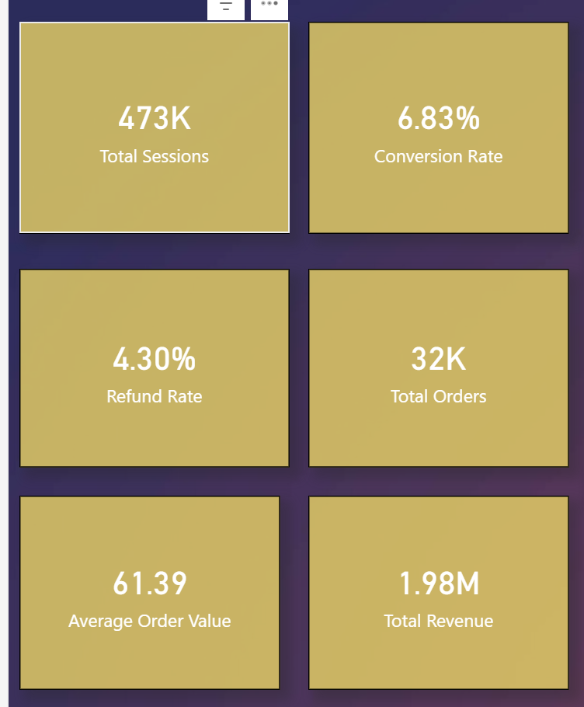

02) Trend Analysis (Time- based visuals)

Visual | Purpose
Monthly Sessions & Orders trend | See traffic and sales over time
Monthly Revenue Trend | Shows monetization pattern
Conversion Rate Over Time | Track efficiency improvements
Average Order Value Over Time | Shows spending behavior trend
Monthly refund Rate rend | Operational issue tracking
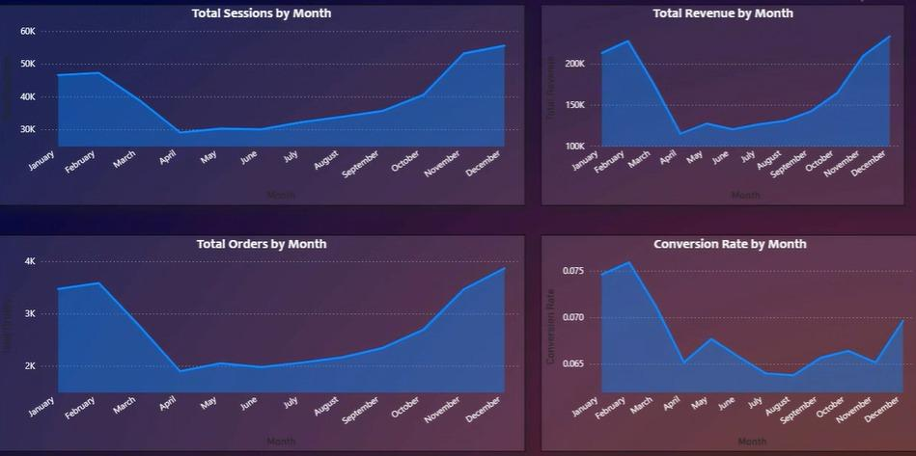

3) Behavioral & Channel Analysis

Visual | Purpose
Revenue By Product | Top revenue-generating items
Conversion by Channel | Which source converts best
Repeat Customer Behavior( New vs Repeat) | Understand loyalty impact
Device - level Performance | Compare Desktop VS Mobile
Refund & Loss by campaign | Identify Costly Campaigns

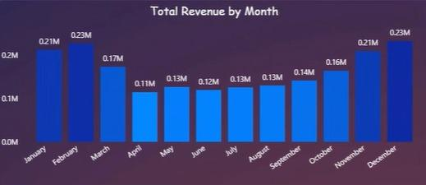

Final Business Recommendations

Summary
The analysis highlights conversion rate, revenue per session, refund rate, and average order value as the most influential metrics driving business decisions. Insights point toward reallocating marketing spend to high-performing channels, improving mobile conversion through UX optimization, reducing refunds via quality improvements, and increasing revenue through product bundling and focused promotion of top sellers. Data cleaning improved accuracy, though gaps such as missing UTMs and limited customer attributes constrained deeper personalization and ROI analysis.

1. Business Relevance and Recommendations

Key Metrics Influencing Decisions
- Conversion Rate (3.5%): Core for optimization.
- Revenue/Session ($1.50): Measures marketing ROI.
- Refund Rate (4.3%): Impacts net revenue.
- AOV ($55): Guides pricing/bundling.

Actionable Recommendations (Derived from Notebook)
- Marketing: Shift to gsearch brand; A/B test landings for +1-2% conversion.
- Conversion: Optimize mobile (lower rates); reduce cart friction.
- Refunds: Analyze patterns, improve quality – save $17k/year by 20% reduction.
- Products: Bundle low-performers; focus on top sellers.
- Expansion: Ramp Q4 marketing; add demographics for segmentation.

2. Reflection Points
- Data Quality Impact: Missing UTMs skewed direct traffic; cleaning improved accuracy but additional fields (e.g., customer demographics) could refine personalization.
- Influential Metrics: Conversion and revenue/session drove recommendations.
- Assumptions: Truncated data assumed representative; no external factors (e.g., economic events).
- Additional Data: Customer feedback, ad spend, competitor benchmarks for ROI analysis.

Conclusion
BearCart’s strongest growth opportunity lies in improving conversion efficiency rather than increasing traffic volume. Enhancing the mobile checkout experience, reallocating marketing spend toward higher-converting brand channels, reducing refunds through better quality control and expectation management, and diversifying product offerings can collectively drive significant revenue gains.

This KPI framework enables a holistic view of performance by clearly connecting traffic, conversion behavior, customer experience, and revenue outcomes. By focusing on conversion efficiency and revenue quality—and by strengthening data quality with richer customer and marketing insights—the business will be well positioned to make high-impact, data-driven decisions and achieve sustainable long-term growth.

